**CCNA – 200 – 301**

(Lab # 2c)

**VTP Configuration for VLAN**

**Objective:**

* Creating two virtual LANs named **VLAN 10 and VLAN 20**.
* VLAN 10 refers to MANAGEMENT while VLAN 20 refers to ADMINSTRATION.
* Network IP is 192.168.10.0 for all PCs configured in VLAN 10 while Network IP is 192.168.20.0 for all PCs configured in VLAN 20.
* Configuring switchports of switches in access and trunking mode for VLAN 10 & VLAN 20.
* For switch (SW0), the ports **f0/1** and **f0/2** are configured to be accessed in **VLAN 10**, the port **f0/3** is configured to be accessed in **VLAN 20** and port **f0/4** is configured as **Trunk**.
* For switch (SW1), the ports **f0/1** is configured to be accessed in **VLAN 20**, the ports **f0/4 and f0/5** are configured as trunk.
* For switch (SW2), the ports **f0/1** and **f0/2** are configured to be accessed in **VLAN 10**, and port **f0/5** is configured as trunk.
* Configuring VTP for all switches.
* SW0 will be configured as **VTP Server** while SW1 and SW2 will be configured as **VTP Client**.
* VTP domain name will be **axiom.edu.pk** and password will be **12345**.
* Showing the results by pinging between the devices in both VLANs.

**Logical Topology in Packet Tracer**

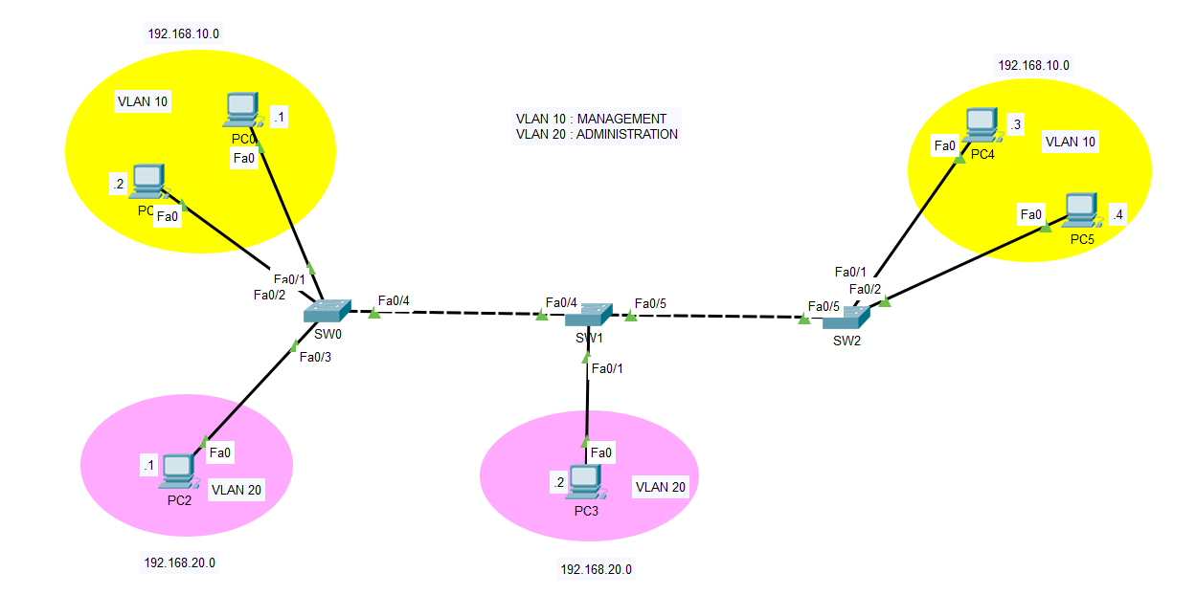

Configuring Switch (SW0) for VLAN 10 & 20 & Trunking

SW0>enable

SW0#configure terminal

SW0(config)#vlan 10

SW0(config-vlan)#name MANAGEMENT

SW0(config-vlan)#exit

SW0(config)#vlan 20

SW0(config-vlan)#name ADMISTRATION

SW0(config-vlan)#exit

SW0(config)#interface range fastEthernet 0/1-2

SW0(config-if-range)#switchport mode access

SW0(config-if-range)#switchport access vlan 10

SW0(config-if-range)#exit

SW0(config)#interface fastEthernet 0/3

SW0(config-if)#switchport mode access

SW0(config-if)#switchport access vlan 20

SW0(config-if)#exit

SW0(config)#interface fastEthernet 0/4

SW0(config-if)#switchport mode trunk

SW0(config-if)#exit

SW0(config)#do show vlan

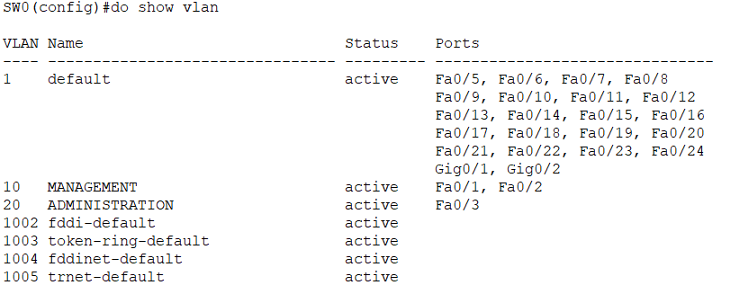

Configuring Switch (SW1) for VLAN 20 & Trunking

SW1>enable

SW1#configure terminal

SW1(config)#vlan 20

SW1(config-vlan)#name ADMISTRATION

SW1(config-vlan)#exit

SW1(config)#interface fastEthernet 0/1

SW1(config-if)#switchport mode access

SW1(config-if)#switchport access vlan 20

SW1(config-if)#exit

SW1(config)#interface range fastEthernet 0/4-5

SW1(config-if-range)#switchport mode trunk

SW1(config-if-range)#exit

SW1(config)#do show vlan

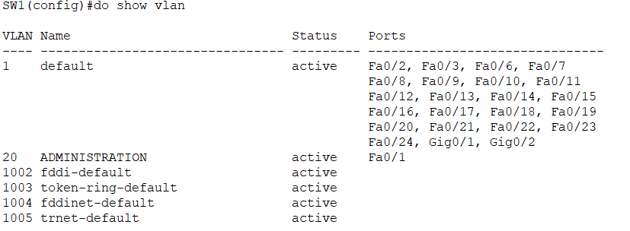

Configuring Switch (SW2) for VLAN 10 & Trunking

SW2>enable

SW2#configure terminal

SW2(config)#vlan 10

SW2(config-vlan)#name MANAGEMENT

SW2(config-vlan)#exit

SW2(config)#interface range fastEthernet 0/1-2

SW2(config-if-range)#switchport mode access

SW2(config-if-range)#switchport access vlan 10

SW2(config-if-range)#exit

SW2(config)#interface fastEthernet 0/5

SW2(config-if)#switchport mode trunk

SW2(config-if)#exit

SW2(config)#do sh vlan

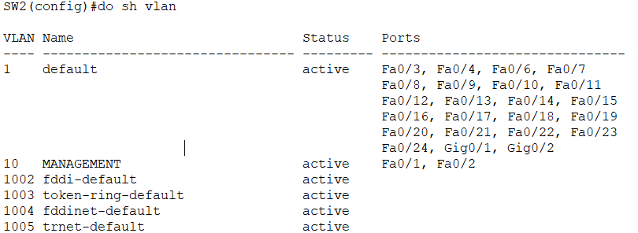

*Pinging from PC2 (VLAN20) to PC0 (VLAN20): Successful*

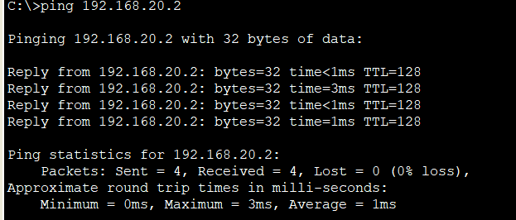

*Pinging from PC0 (VLAN10) to PC4 (VLAN10): Unsuccessful*

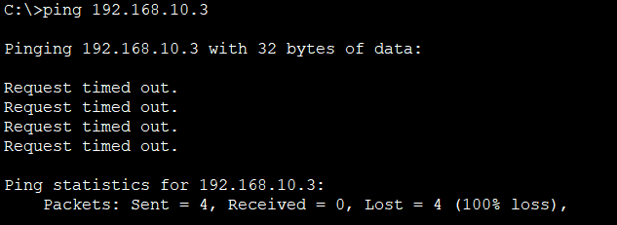

As you can see the ping from same network and in same VLAN has not been successful, but why? The reason is that all switches do not have same entries in VLAN database. For example, SW0 includes VLAN 10 & 20, SW1 includes VLAN 20 only and SW2 includes VLAN 10 only. As the matter of fact, all switches in intra-VLAN communication must have same number of VLAN entries in database. So, in this case, if we create VLAN 10 in SW1 and VLAN 20 in SW2, then the network will work fine as all switches are going to have same number of VLAN. But this is not the permeant solution as we will implement the VTP in this case later as workable solution.

Creating VLAN 10 in Switch (SW1)

SW1>enable

SW1#configure terminal

SW1(config)#vlan 10

SW1(config-vlan)#name MANAGEMENT

SW1(config-vlan)#exit

SW1(config)#do sh vlan

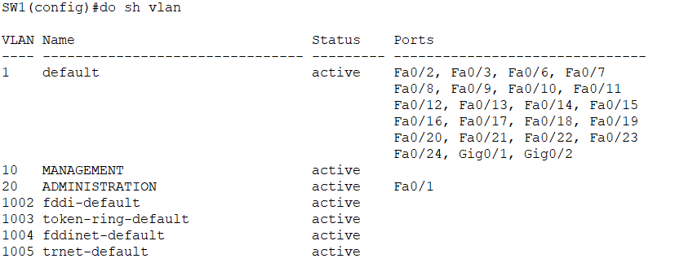

Creating VLAN 20 in Switch (SW2)

SW2>enable

SW2#configure terminal

SW2(config)#vlan 20

SW2(config-vlan)#name ADMINISTRATION

SW2(config-vlan)#exit

SW2(config)#do sh vlan

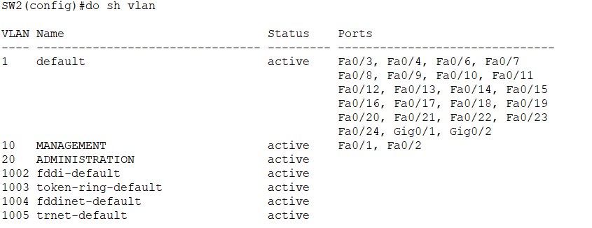

*Pinging from PC0 (VLAN10) to PC4 (VLAN10): Successful*

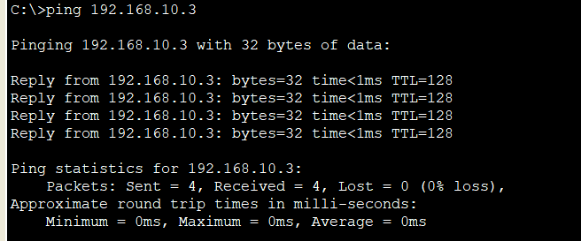

Checking VTP status of all switches before configuring VTP

To check VTP status of switch you can simply issue “**show vtp status”** command in privileged EXEC mode

VTP Status of switch (SW0)

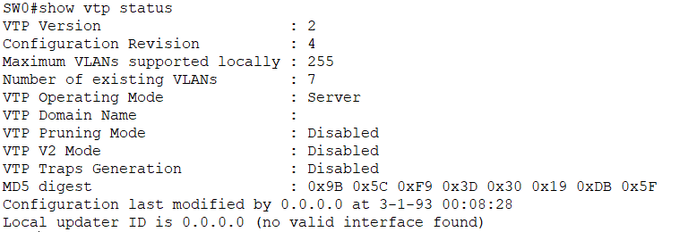

VTP Status of switch (SW1)

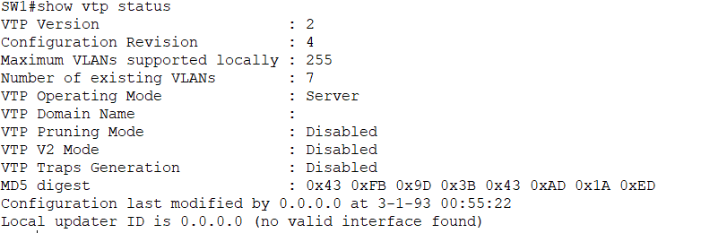

VTP Status of switch (SW2)

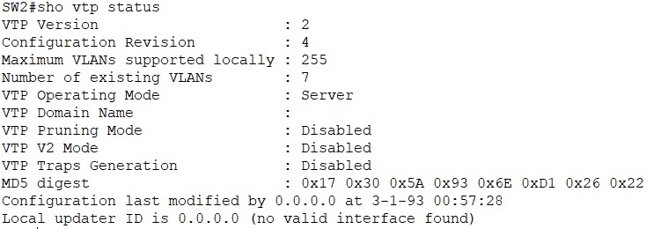

Now we need to configure the following for VTP to work

* VTP domain name
* VTP password
* VTP operating mode
* VTP version

Configuring VTP for switch SW0

SW0>enable

SW0#configure terminal

SW0(config)#vtp domain axiom.edu.pk

SW0(config)#vtp password 12345

SW0(config)#vtp mode server

SW0(config)#vtp version 2

SW0(config)#do show vtp status

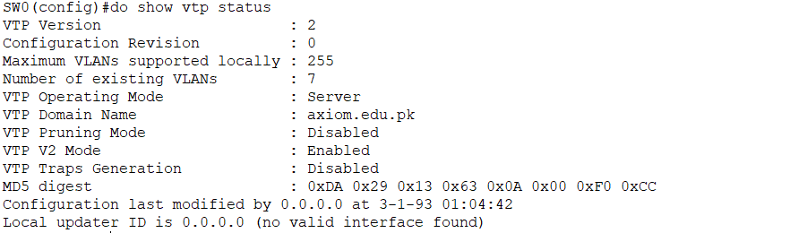

Configuring VTP for switch SW1

SW1>enable

SW1#configure terminal

SW1(config)#vtp password 12345

SW1(config)#vtp mode client

SW1(config)#vtp version 2

SW1(config)#do show vtp status

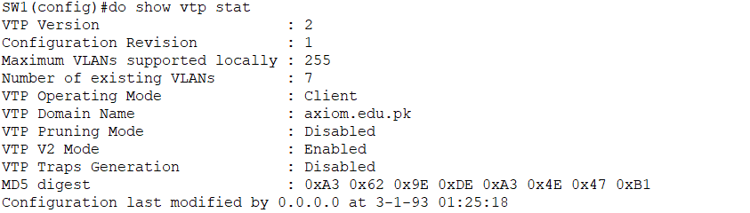

Configuring VTP for switch SW2

SW2>enable

SW2#configure terminal

SW2(config)#vtp password 12345

SW2(config)#vtp mode client

SW2(config)#vtp version 2

SW2(config)#do show vtp status

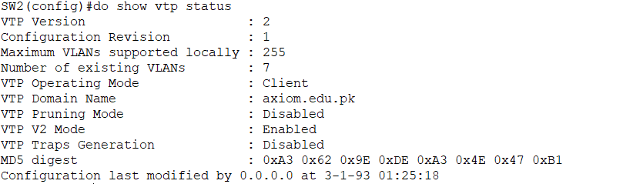

Adding new VLAN to switch SW0 (VTP Server)

SW0>enable

SW0#configure terminal

SW0(config)#vlan 30

SW0(config-vlan)#name MARKETING

SW0(config-vlan)#do show vlan

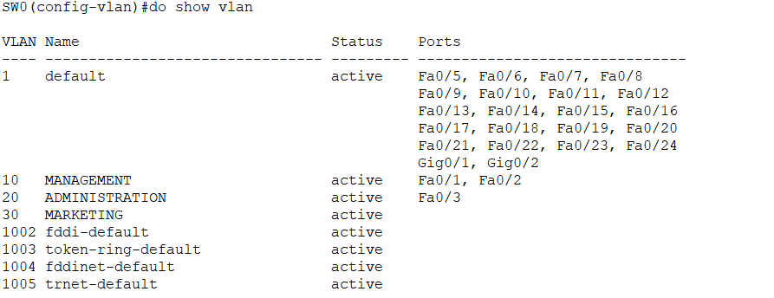

Now we check the VLAN status of SW1 and SW2, we will see that newly added VLAN 30 (Marketing) in SW0 will also be present there; this is due to the VTP we have configured.

